PACKET ANALYSIS USING WIRESHARK
1. Introduction
Packet analysis is the process of examining data as it travels across a computer network. Network communication is divided into small pieces of data called packets. Each packet contains information that can help us understand what is happening during communication between devices. For this project, wireshark was used to capture and analyze network traffic. Three different protocols were examined:
- ICMP (Ping)
- DNS
- HTTP
The captures were filtered in wireshark, screenshots were taken as evidence, and the packet captures were saved as .pcap files.
2. Tools Used
- Wireshark: Wireshark is a network packet analysis tool. It allows network traffic to be captured and examined.
- PowerShell: Powershell was used to generate some of the network traffic that was captured by wireshark.
- Web Browser: A web browser was used to generate http traffic by visiting an http website.
- WLAN/Wi-Fi network interface: The wlan/wi-fi interface was selected in wireshark because it was the active network interface being used for the internet connection.

3. ICMP (Ping) Analysis
What is ICMP?
ICMP stands for Internet Control Message Protocol. It is commonly used to check whether a device or server can be reached over a network. A common example is the ping command.
What I Did:
First, I opened wireshark and selected the active wi-fi interface.
I started a packet capture and then opened powerShell.
I initially tried: ping 8.8.8.8
It failed, then I tested the connection using: ping google.com
This worked successfully and produced replies from Google’s server. While the ping was running, wireshark captured the network packets. After stopping the capture, I used the following wireshark display filter:
Icmp
This filtered the capture so that only ICMP packets were displayed.
My Observation:
The capture showed ICMP echo request and ICMP Echo reply packets. The echo request is sent from my computer to the destination, while the Echo Reply is sent back in response. Information that can be observed includes:
- Source IP address
- Destination IP address
- ICMP packet type
- Packet length
- Other packet details
Importance of icmp traffic
- ICMP is important for network troubleshooting because it can be used to determine whether a device is reachable and whether communication between two devices is working.
- It can also be useful during cybersecurity investigations because analyzing ICMP traffic can help an analyst understand network activity.

Screenshot

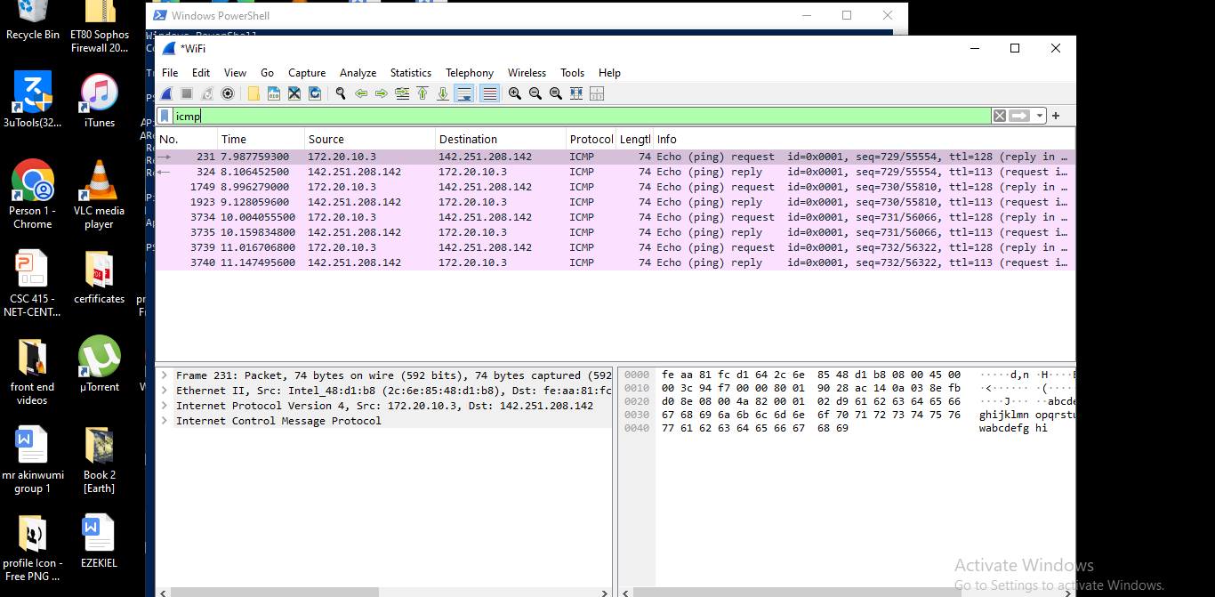

The screenshot shows the wireshark window with the filter and the captured icmp packets.

4. DNS Analysis
What is DNS?
DNS stands for Domain Name System. DNS allows computers to translate human-readable website names, such as google.com into ip addresses that computers use to communicate with servers. without dns, users would generally need to remember numerical IP addresses instead of website names.
What I Did
I started another wireshark capture using the same wi-fi interface.
I then opened powerShell and ran: nslookup Google.com.
The command returned information about Google’s domain.
The powershell output included a dns server address and a non-authoritative answer.
The non-authoritative answer was not an error. It simply meant that the response came from a dns server that was not the authoritative dns server for google’s domain. wireshark captured the dns communication generated by the command.
I then applied the wireshark display filter: dns.
My Observation
The wireshark capture showed dns packets containing queries and responses. The query asks the dns server for information about a domain, while the response provides the requested information. Information that can be observed includes:
- The domain being queried
- Source and destination addresses
- DNS server information
- The IP address returned for the domain
- DNS query and response details

Importance of dns traffic
- it is an important part of normal internet communication because it allows users to access websites using domain names.
- From a cybersecurity perspective, this traffic can also be analyzed to identify unusual or potentially suspicious domain requests.

Screenshot
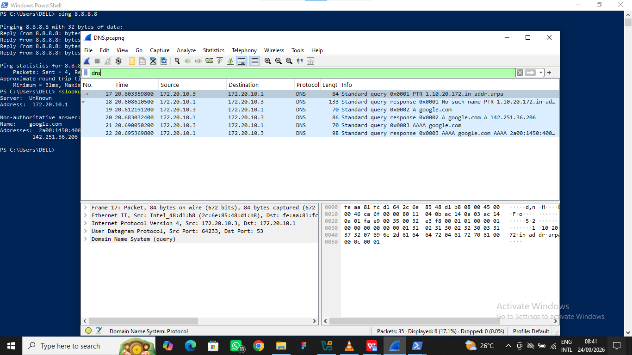

The screenshot shows the wireshark window with the filter and the captured DNS packets.

5. HTTP Analysis
What is HTTP?
HTTP stands for Hypertext Transfer Protocol. It is a protocol used for communication between a web browser and a web server. Example is when a browser requests a webpage, http can be used to send the request to the server and receive the webpage in response.
What I Did
I started another wireshark capture using the active wi-fi interface.
Then i opened an http test website in my browser.
I used an http website rather than a normal https website because the purpose of this exercise was to capture and analyze http traffic.
After visiting the website, I returned to wireshark and stopped the capture.
I applied the display filter: http. This filtered the traffic and displayed http packets.
My Observation
The wireshark capture showed http communication between my computer and the web server. Depending on the packet, information that can be observed includes:
- Source IP address
- Destination IP address
- HTTP requests
- HTTP methods such as GET
- Server responses
- Other HTTP communication details
Importance http traffic
- Http does not encrypt the contents of web communication. which means that information transmitted using plain HTTP can potentially be observed by someone monitoring the network.
- It demonstrates why encrypted communication such as HTTPS is important when protecting information transmitted over the internet.

Screenshot

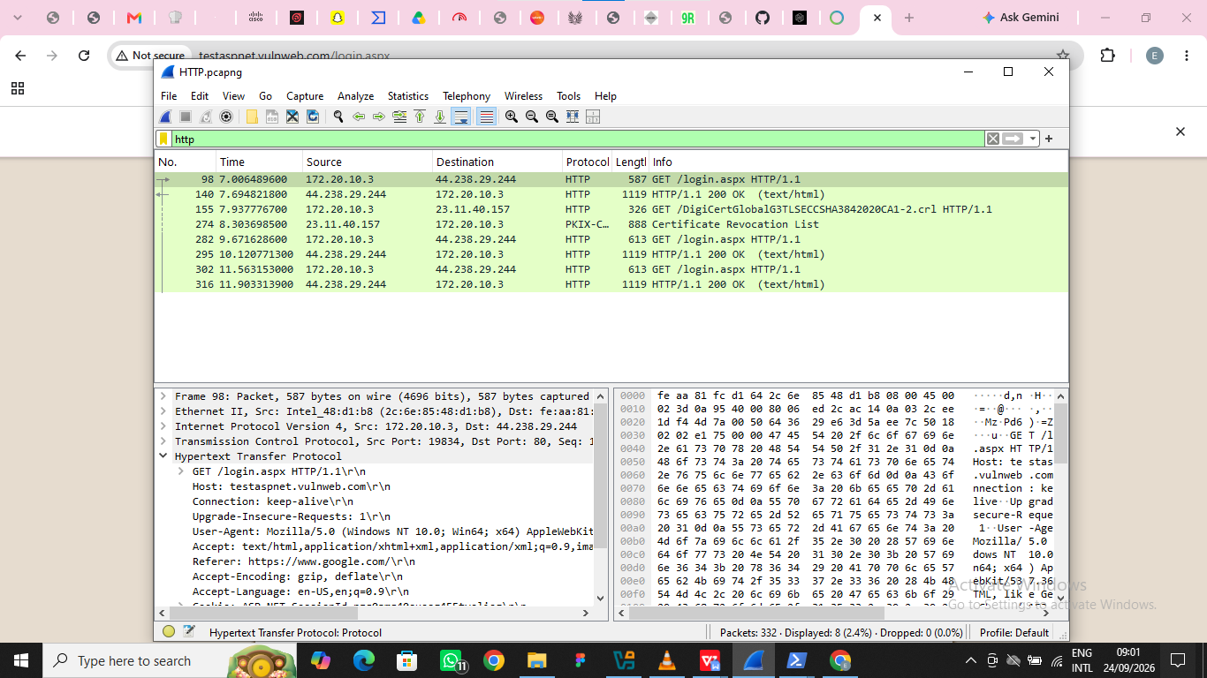

The screenshot shows the wireshark window with the filter and the captured HTTP packets.

